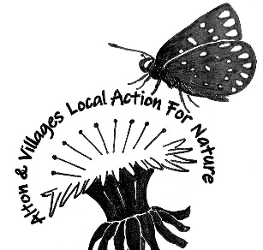
PRESS RELEASE
ALTON’S GARDEN TRIBUTE TO GILBERT WHITE IN HIS 300TH BIRTHDAY YEAR

A unique partnership between the Gilbert White Museum in Selborne, Ecochurch in Alton and Alton and Villages Local Action for Nature (AVLAN) has created a very special flower bed at All Saints Church on Queen’s Road, visible to passers-by from the pavement and close to the path leading to the church door.
The garden commemorates the 300th birthday of Gilbert White (1720 -1793), the renowned naturalist who was also a very keen gardener.
Lesley Willis from AVLAN said, “From the outset (at the beginning of 2020) the gardeners at Gilbert White Museum have been most supportive and helpful, culminating in Keith coming to All Saints to help strip turf from the marked-out plot. His expertise and stamina made a challenging job seem easy! [photo]. The gardeners advised us on the flowering plants Gilbert White was known to have grown at The Wakes, and they donated a number to get us started.”
A small group of volunteers from AVLAN spent a happy afternoon planting the garden [photos]. Most of the flowers are insect-friendly: important because we all need to help struggling bees and butterflies – their numbers are in serious decline - by planting nectar-rich flowers wherever we can.
A spokesperson for All Saints Church said that “the Congregation love the idea of such an important flower bed in their churchyard”. One of the objectives of Ecochurch is to look after church land in a wildlife-friendly way. Members of the Congregation will help with watering, weeding and deadheading. The Church is on the Pilgrim’s Way from Winchester to Canterbury.
Jenny Griffiths from AVLAN said, “This project has been delayed by six months because of the Covid pandemic, so it was particularly joyous to plant out this flowerbed, so full of promise for 2021. We shall all look forward to seeing the early-flowering aconites, crocuses and pulmonaria. Gilbert White is one of my heroes – he taught us how to record the natural world around us, how to observe the timing of the seasons. He was very aware of the climate. And he was closely connected to Alton, coming into the town frequently on horseback.”
Donations from members of the Congregation and a grant from Cllr. Steve Hunt will fund an interpretation board, which will be erected during the winter.
AVLAN hopes that their next project will be to develop a wildlife garden nearby. They are just waiting for permission from EHDC to use a small area of grass on the approach to Alton from the West to encourage pollinating insects and other wildlife.

AVLAN is a group within Alton Climate Action & Network, which brings people together in Alton and the surrounding villages to tackle the climate and environmental crises. www.altonclimatenetwork.org.uk

For more information, contact Jenny Griffiths
Jenny@GriffHobbs.co.uk

