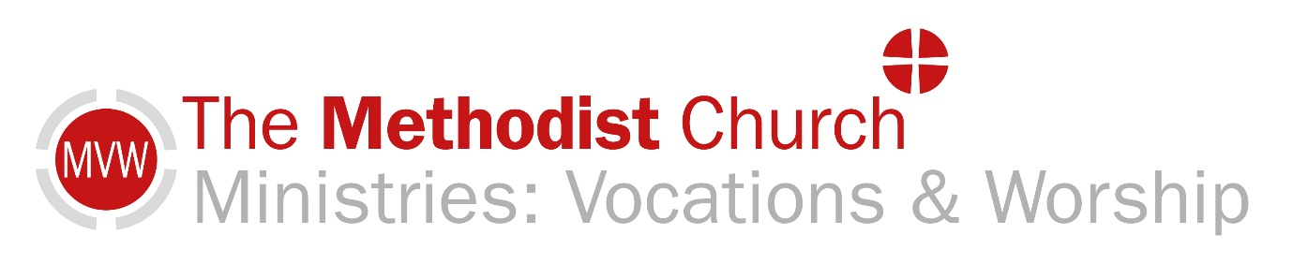
Sunday 21st February 2021
This short act of worship has been prepared for you to use whilst we are unable to use Methodist Church premises. We invite you to spend a few moments with God, knowing that other people are sharing this act of worship with you.

Opening Prayer
We come before you Almighty God, ever mindful that you have called us as your own. Lead us in your truth and teach us your paths of steadfast love and righteousness. Amen.
Hymn: “Guide Me O Thou Great Jehovah” Stf 465
Sing/ Read /pray /proclaim the words or listen to it here:
https://www.youtube.com/watch?v=5j48TLIRb4Q

Guide me, O thou great Jehovah,
pilgrim through this barren land;
I am weak, but thou art mighty;
hold me with thy powerful hand:
Bread of heaven, Bread of heaven,
feed me now and evermore;
feed me now and evermore.

Open thou the crystal fountain
whence the healing stream shall flow;
let the fiery, cloudy pillar
lead me all my journey through:
strong Deliverer, strong Deliverer,
be thou still my strength and shield;
be thou still my strength and shield.

When I tread the verge of Jordan
bid my anxious fears subside;
death of death, and hell's destruction,
land me safe on Canaan's side:
songs of praises, songs of praises,
I will ever give to thee;
I will ever give to thee.
William Williams (1717-1791)

Let us pray together
O Lord we lift up our hearts and minds and bless your holy name. For you have created all things and your glory is seen in the heavens and on the earth. Thank you for your bountiful provision and your love that goes before us. May this time of Lent enable us to walk humbly and be mindful of your covenant with us. Forgive us Lord for the words said and deeds done that have been selfish, inconsiderate, or hurtful to others. We thank you for your mercies that are new to us each day and that wash us clean. In Jesus Name. Amen

Today’s Reading from the Old Testament: Genesis 9:8-17
Today’s Gospel Reading: Mark 1:9-15
Time to Reflect.
Here we are at the beginning of a new Church season in Lent 1. There are two readings for today. The Gospel passage should be familiar to folk as portions of it have already featured twice in this year’s lectionary and the Genesis passage which I find particularly applicable to our present situation worldwide.
Noah and his family have been restricted to an Ark for 378 days, not just 40 days. Which is so similar to how long this Pandemic has been making our lives difficult. When Noah disembarks and makes sacrifices to God, then God promises to establish a covenant which has the rainbow as a sign.
What will you sacrifice to God to open a way for God to bless you? Our hands are full of many different things that we need to let go of before we can take up new things.
Just as God wiped the earth clean of all wickedness by way of the flood waters so too does the Baptism of repentance wash us clean.
The wilderness, like Lent is also a time for reflection, fasting and spending time in prayer as we prepare for what God is going to do in us and through us.
What are the “struggles” that you have faced in this last year? What path will you take in the Lenten season ahead?
Take a time to sit quietly.
A time of prayer
Lord God, we pray for those who find themselves in restricted spaces and unexpected places.

We pray for places affected by climate change,
areas where water is scarce and crops fail,
places where flooding is affecting people’s homes.

We pray for those who are homeless and have lost everything through earthquake or fire.

We pray for those who wait for medical results, for those who are ill in hospital or at home.
For those who have lost their jobs and those who await news about benefits.

We pray for our healthcare workers, nurses and doctors, essential service workers, teachers and police.

For our children whose education has been so badly affected, and parents who are juggling time constraints.

For those who are grieving the loss of loved ones.
For Religious leaders and funeral parlours who minister to the bereaved.

For those who are working on the Vaccine rollout, scientists, government leaders, economists, and medical aid associations.

Breathe new life into your people and all circumstances as we approach Easter. May we always know your presence with us. Amen

The Lord’s Prayer
Our Father ……
Hymn: Listen to “Waymaker” Michael W. Smith. https://www.youtube.com/watch?v=SE_M9noEhNE
or sing a verse of a hymn that comes to mind.
A prayer of blessing
May Almighty God, who has called us by His grace bless and keep us by confirming and strengthening us through Jesus Christ, our Lord, and fill us with the power of the Holy Spirit to His instruments of peace in the world. Amen.
Original Materials by Fiona Calverey
All Hymns reproduced under CCLi 1144191.
Local Churches please insert CCCLi No here

We are grateful to all the Ministers and Local Preachers from around the Connexion who have contributed to Worship at Home. This resource is administrated by Ministries: Vocations and Worship in the Connexional Team. We aim to continue to provide these resources until the end of August 2021.

Genesis 9:8-17
Then God said to Noah and to his sons with him, ‘As for me, I am establishing my covenant with you and your descendants after you, and with every living creature that is with you, the birds, the domestic animals, and every animal of the earth with you, as many as came out of the ark. I establish my covenant with you, that never again shall all flesh be cut off by the waters of a flood, and never again shall there be a flood to destroy the earth.’ God said, ‘This is the sign of the covenant that I make between me and you and every living creature that is with you, for all future generations: I have set my bow in the clouds, and it shall be a sign of the covenant between me and the earth. When I bring clouds over the earth and the bow is seen in the clouds, I will remember my covenant that is between me and you and every living creature of all flesh; and the waters shall never again become a flood to destroy all flesh. When the bow is in the clouds, I will see it and remember the everlasting covenant between God and every living creature of all flesh that is on the earth.’ God said to Noah, ‘This is the sign of the covenant that I have established between me and all flesh that is on the earth.’ (NRSV)

Mark 1:9-15

The Baptism of Jesus
In those days Jesus came from Nazareth of Galilee and was baptized by John in the Jordan. And just as he was coming up out of the water, he saw the heavens torn apart and the Spirit descending like a dove on him. And a voice came from heaven, ‘You are my Son, the Beloved; with you I am well pleased.’

The Temptation of Jesus
And the Spirit immediately drove him out into the wilderness. He was in the wilderness for forty days, tempted by Satan; and he was with the wild beasts; and the angels waited on him.

The Beginning of the Galilean Ministry
Now after John was arrested, Jesus came to Galilee, proclaiming the good news of God, and saying, ‘The time is fulfilled, and the kingdom of God has come near; repent, and believe in the good news.’ (NRSV)

