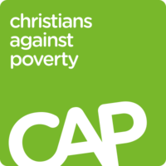
UNMANAGEABLE DEBT ? A LIFE-CONTROLLING HABIT ?

Hello, I’m Mark Rumsby and I’m the Centre Manager of the Alton branch of the charity Christians Against Poverty, better known as CAP. We provide free help to anyone, regardless of background, in complete confidentiality.

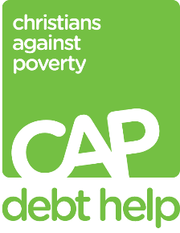
ITV Meridian news recently featured our free Debt Help Service, which we’ve been running in the Alton area for nearly 7 years. You can find their report at www.itv.com/news/meridian/money.

Over the years we’ve got to know over 170 individuals or families locally who’ve needed help with debt. Most live in social housing and over half are single women, many of them single mums. If their main income is benefits, they may struggle to pay basic bills such as rent, council tax, or water bills – and this is often how they run up debts. We’ll help anyone who has debts, whether it’s £500 or £50,000 or more. And we don’t judge anyone as to why they got into debt in the first place.

With CAP, our approach is to provide compassionate personal support – normally visiting people in their homes. At the same time we pray with them, and if they wish, tell them about Jesus. We achieve all that in Alton through a great team of 2 Debt Coaches and about 25 helpers - all Christians - drawn from 13 local churches. We work with CAP’s national headquarters to provide a professional debt service where the charity deals with all of a person’s creditors until they get free of debt. In Alton we’ve succeeded in getting 52 households out of debt so far, which is a huge relief to those people, and several of our client friends have opened their lives to Jesus.
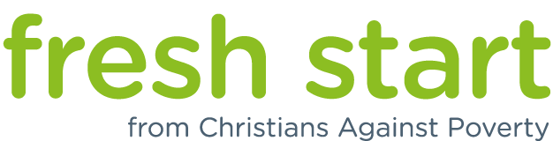
Our second service is called Fresh Start. Fresh Start helps people who want to change a life-controlling habit such as smoking, gambling, over-eating, internet or social media addiction, shopping compulsions, binge drinking, soft drugs, etc.

The free 8-week course, inspired by the Bible and the Twelve Steps of Recovery principles, is led by trained coaches who also offer 1-to-1 coaching. The groups provide supportive communities where people can meet regularly and work through a plan of action in order to break free from these dependencies. Our team of 5 Fresh Start Coaches has run 6 courses in Alton so far, and several people have successfully tackled habits of smoking, gambling, over-spending, alcohol and drugs.

There are various ways that you can help this work:
- If there’s anyone you know in financial difficulty with unmanageable debts, urge them to call CAP on 0800 328 0006. More information at www.capdebthelp.org. If you’d like a leaflet, contact me.
- If you know anyone who wants to tackle a life-controlling habit, encourage them to call me for details of the next course. More information at www.capfreshstart.org. If you’d like a leaflet, contact me.
- Pray. If you’d like to receive a monthly email with prayer points, contact me.
- You might wish to join our team as a helper. If so, contact me.

Thank you and bless you all. Mark Rumsby – 07769 030913 – alton@capuk.org

