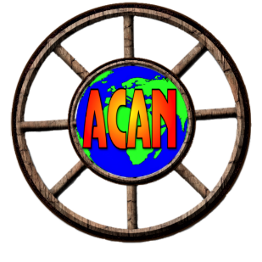
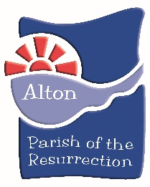
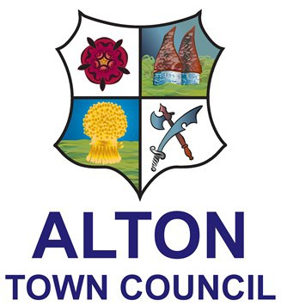

Alton Community Share – presents
“Saturday morning Takeaway”

By the community for the community
We’re having a clear out to make space for new donations. We’ve always been powered by the generosity of our local community, so it’s only right that we should give something back too.
On Saturday 22nd May we’re opening our doors for everyone to help themselves. We’re inviting local schools, pre-schools, care homes, charities and anyone who would like to come to St Lawrence Parish Centre from 10.00-12.00 and takeaway whatever they like, books, toys, games and jigsaws. We need to free up space for new donations to refresh our stocks.
We’ve been open for nearly a year and we’ve done our best to support local families to find nearly-new toys, games and jigsaws, to help keep busy throughout the pandemic. We’re planning ‘Saturday Morning Takeaway’ as a stock clearance to make way for new donations. We need to evolve to keep our stock fresh and interesting to attract new visitors.
Do you know someone who runs an after school club, or a holiday club. Perhaps you organise a day care centre and would like some jigsaws. Does your local school need some more reading books? We’re inviting everyone to come and take their share.
Our mission has always been to help people keep busy at home, save money by not needing to buy new, and reduce waste by re-using things which still have plenty of life left in them. We’re keen to continue providing a lending library to encourage families to think about their consumption and make it easy to re-use ‘stuff’.
We’ll be accepting new donations from June to ensure we have plenty of tempting toys and games in store ahead of the summer holiday period.
Strict hygiene and control of infection rules are followed at all times. Items donated are quarantined to ensure there is no possibility of transmitting Covid-19 from them.

