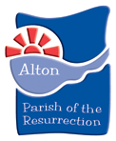
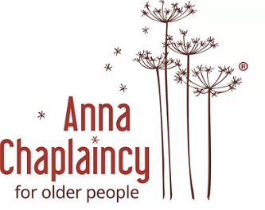

Job Description

Job Title: Anna Chaplain
Main Purpose of the Post

To promote the spiritual welfare of older people in residential care, sheltered housing and in the wider community, particularly those facing challenges of living independently
To develop and lead a team of volunteers who, together with the successful applicant, can offer spiritual and emotional support to older people, and extend such support to their relatives, and the staff who look after them.

Main Duties and Responsibilities
- To build, manage and empower teams of Anna Friends and other volunteers, helping others to acquire the skills required for effective work with older people and their carers, including signposting them to training opportunities.
- To support Anna Friends and other volunteers, offering networking opportunities and working closely with existing pastoral teams within the parish
- To be an advocate for Anna Chaplaincy within the wider community and engaging with local media to raise awareness and increase support
- Pioneer opportunities for intergenerational work
- Work closely with existing ministry teams within the Parish and the Methodist church, and liaise with other Anna Chaplains locally and nationally
- Keep up to date with research into issues relevant to the spiritually of aging and attend appropriate training
- Prepare and deliver a range of worship services for older people
- Promote and advocate the work of Anna Chaplaincy to new supporters and possible funders in the wider area.
- To take part in, and contribute to, the worship of the Greater Alton Project Covenant Churches at appropriate times.
- Work closely with older people, their relatives, staff and carers to:
  - Better understand the spiritual issues older people face in later life
  - Help and support relatives with their task of caring for older people in their family.
  - Offer spiritual support to staff dealing with the demanding, but often rewarding, circumstances that they may encounter when dealing with older people in their care.

- Keep records of work undertaken and write annual reports.

