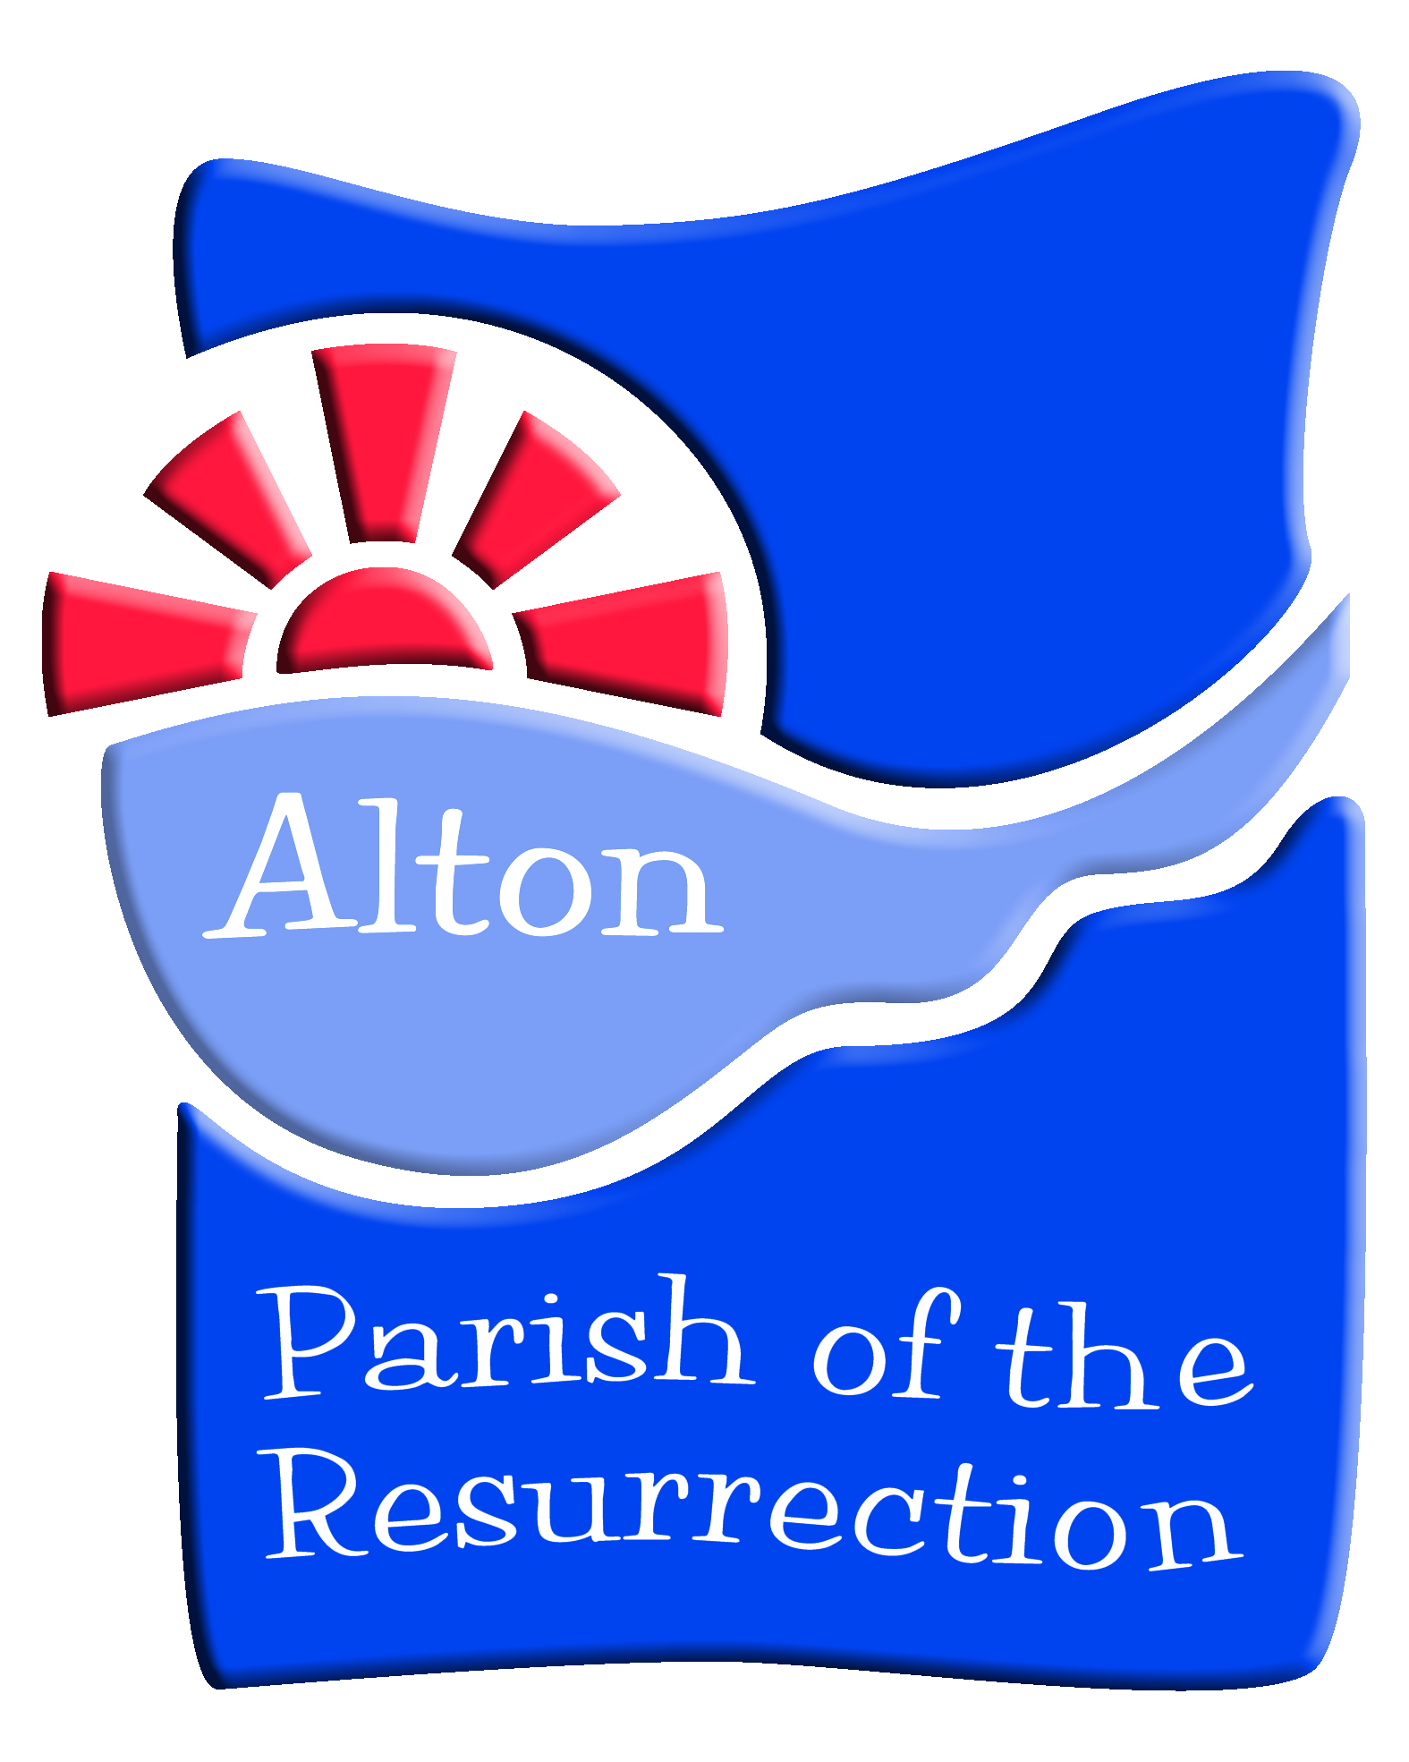
The Parish of the Resurrection Alton (POTR)
Role of the Parochial Church Council (PCC)
its Committees and Task Groups

Introduction
Vision and strategy, governance and practical mission and ministry cannot be held in one single central committee. Therefore a system of PCC groups, Open Forum meetings, and task and finish groups gives PCC members and the wider membership of the POTR a chance to focus in on particular areas of the work of the church and build up the knowledge and experience that can be used to support and develop those areas of work, and at the same time, highlight for other church members the key issues that need to be considered by the PCC in reaching decisions about priorities for the church community.
Each of these groups have regularly reviewed and agreed Terms of Reference. Brief overviews are given here
Local Church Groups
Responsible to the PCC for maintaining the fabric, furnishings and fittings of the churches and where appropriate church yards and burial areas - working from the QI reports, agreeing annual maintenance plans and working with volunteer team. Overseeing activities which take place in each church building and responsible for local church activity as agreed in the POTR calendar. In consultation with the appropriate churchwardens there is delegated responsibility to spend up to £200 (according to funds being available) without recourse to the Finance & Administration Group or the Treasurer.

Finance and Administration Group
Responsible to the PCC for ensuring that the resources necessary to implement the vision of the church community are available. Proposing an annual POTR budget and subsequently monthly and quarterly monitoring. Has oversight of the Parish Office, data systems, policies and their reviews, risk and charity obligations.

Community and Outreach Group
Responsible for co-ordination and recommendation of events, activities community engagement which sit within the Parish Vision and the Parish calendar. To establish a set criteria to underpin and oversee this.

Worship and Spiritual Life Group – Ministry Team
Responsible for evaluating, planning and resourcing the worship, discipleship and courses and other activities which deepen the spiritual life of the parish community.

Executive Group
Responsible as The Standing Committee which has conversation and can make decisions between PCC Meetings; as the Buildings Group which appoints teams for major projects, ensures maintenance plans are in place; agrees fabric and maintenance contracts in liaison with the Treasurer; and acts as a forum for churchwardens to share key ideas.

Staff & Volunteers Group
Responsible for appointment and recruitment of contracted staff – contracts of employment & job descriptions; the review of salaries; compliance with legislative requirements and agreed policies; monitoring wellbeing; reviewing working conditions

Youth, Children & Family Support Group
Responsible for supporting the Parish’s ministry with these groups. To particularly support the YCF Worker in ministry with these groups and according to the YCF Worker job description.

This structure will leave some activities as the responsibility of the PCC as a whole or delegated to a task or working groups.

The Parish of the Resurrection Alton (POTR) Constitution
Introduction
The Parish of the Resurrection comprises the previous parishes of Alton All Saints and Alton St Lawrence which parishes have been united by a scheme under the Pastoral Measure 1983.
The churches of All Saints, St Peter’s & St Lawrence are all parish churches of the Parish of the Resurrection.
By a subsequent scheme the parish of Holybourne has become part of the Parish of the Resurrection. The Church of the Holy Rood also becomes a designated parish church.
The Parish of the Resurrection Alton is a covenanted partner with Alton Methodist Church in a Local Covenant Partnership called the Greater Alton Project.
This constitution is drawn up with reference to the current Church Representation Rules.
The Parish of the Resurrection is a registered charity. It’s charity
number is 1136970.
Elections
Elections to the PCC will be held at the APCM.

Electoral Roll
A new electoral roll shall be prepared no later than six years after the date in which the present electoral roll was prepared.

Churchwardens
The Churchwardens Measure 2001 makes the following provision for parishes with more than one parish church.
Where by virtue of a designation made by a pastoral scheme or otherwise a parish has more than one parish church, two churchwardens shall be appointed for each of the parish churches, and this Measure shall apply separately to each pair of churchwardens, but all the churchwardens shall be churchwardens of the whole parish except so far as they may arrange to perform separate duties in relation to the several parish churches.
All four designated parish churches elect two churchwardens, so up to eight altogether. All of these wardens will be wardens of the parish but their duties will be related to each of the churches as follows:
For each of the parish churches one of the churchwardens will be the chair of the Local Church Group for that church.
PCC Membership
The Incumbent (Chair)
The Associate Vicar
Any other Minister licensed to the Parish
The Parish Treasurer (ex Officio and elected at the first meeting after each APCM)
7 Churchwardens for the Parish which comprise the following:-
2 Churchwardens for the church of All Saints (one of whom shall be the chair of All Saints Local Church Group)
1 Churchwarden for the church of St Peter’s who will be the Chair of St Peter’s Local Church Group
2 Churchwardens for the church of St Lawrence (one of whom shall be the chair of the St Lawrence Local Church Group)
2 Churchwardens for the church of Holy Rood (one of whom shall be the chair of Holy Rood Local Church Group)
4 other elected lay members, one member representing the congregation of each church in the parish
5 Deanery Synod representatives (at least one from each church)
Officer in attendance: the PCC secretary.
Terms of Service
All Churchwardens will be elected and eligible to serve according to the provisions of section 3 of the Churchwardens Measure 2001.

In 2016, the APCM agreed that a churchwarden can hold the office for up to eight successive years until the annual meeting of the parishioners decide to bring a resolution to change.

Frequency of Meetings
The PCC will meet not less than four times each year and will hold an APCM no later than the end of May each year.

Quorum
There shall be a quorum when at least one third of the total membership of the PCC is present provided that at least one person present is ordained and one person lay.
Standing Committee
There will be a Standing Committee (Exectutive Group) consisting of the Incumbent, Associate Vicar and the churchwardens. The treasurer will also be a member where there are financial implications in excess of the approved budget.

Committees of the PCC and/or Task and Finish Groups
The PCC will authorise committees, and task/finish groups to be responsible for particular aspects of parish activities. The PCC appoints these committees, sets their terms of reference, budgets and receives regular reports. Committees and task and finish groups may be formed according to local needs. The committees and task/finish groups shall have planning and executive functions within the policies approved by the PCC. The chair and membership of committees and task and finish groups will be appointed by the PCC.

The Covenant Council
Representation of the Parish on the Covenant Council of the Greater Alton Project will be:

- The Incumbent
- The Associate Vicar
- Up to 3 other interested and appropriate people from the worshipping communities of the Parish

Terms of Reference
Admin and Finance Group
The Admin and Finance Group is a sub group of the PCC comprising the Treasurer, up to 6 members appointed by the PCC, one of whom shall be appointed Chairman. Other members may be co-opted as necessary. Others may be invited to attend meetings at the discretion of the Chairman. The normal term for membership shall be three years. Members may be re-elected to serve further terms.

Quorum
The quorum for each meeting will be 3 members

Frequency of Meetings
No less than four times per year

Record of Meetings
A written record will be kept for each meeting and submitted to the PCC. Reports on the Parish finances shall be provided to members at intervals during the year.

Functions of the Group

- Prepare an annual budget to be submitted to the PCC for approval after consultation with all PCC committees and other groups undertaking mission and ministry across the parish
- Review monthly financial reports on income and expenditure and report to PCC and members as appropriate.
- Receive reports on the financing and management of major projects by project teams and Local Church Groups and making recommendations to the PCC as necessary.
- To act as the Stewardship Group keep Parish Giving under review and recommend proposals for future campaigns.
- Routinely review all policies and propose amendments to the PCC. Periodically review implementation of the policies
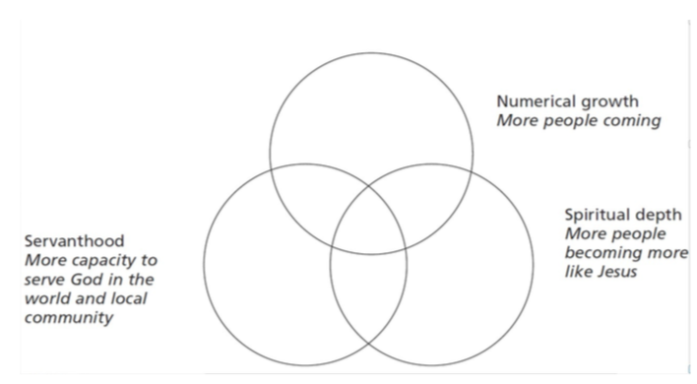
- Review Admin and Finance working arrangements annually in conjunction with officers and the Vicar.
- Arrange annual appraisal of Parish Administration employees
- Oversee the implementation of GDPR
- Oversee POTR obligations as a charity in respect of governance, financial regulation and operational procedures.

Terms of Reference
Community & Outreach Group

The Community & Outreach Group is a sub-group of the PCC and shall form to co-ordinate and recommend events, activities community engagement It will consist of nominated members of the PCC plus those who will help with the above as requested and invited
Quorum
A quorum at each meeting shall be 4 members.

Frequency of meetings
Up to six times a year

Record of Meetings
A written record will be kept for each meeting and submitted to the PCC.

Term of Office
Volunteers shall be members until they wish to step down from the Group

Responsibilities and Functions of the Community & Outreach Group

- review/revise and update the Parish calendar in communication with the Parish Office.
- report to the PCC with a short agreed written record of each of their meetings.
- obtain approval from the PCC regarding budget for events, suggestions and recommendations from the group
- determine from a set criteria which activities. events and community engagement will be promoted and organised - see separate criteria below
- recruit and liaise with lead volunteer for each activity/event
- obtain and evaluate feedback relating to events and activities scheduled, to be communicated with the group, PCC and Parish when appropriate.
- prepare and update as necessary a checklist for events to be used by organisers
- put forward ideas to the Ministry Team, Executive Group and PCC
- oversee a communication process for activities, events and community engagement in conjunction with the Parish Communication Officer in the Parish Office (Ellie Elder)
- seek out local and national Christian events which can be promoted and part of the parish calendar
- ask key post holders and volunteers to attend certain meetings of the Community and Outreach Group to help in the calendar setting process

Criteria Venn Diagram (taken from Leading Your Church into Growth)

Terms of Reference
Worship & Spiritual Life Group – The Ministry Team
The Worship & Spiritual Life Group is a sub-group of the PCC undertaken by The Ministry and to be responsible for evaluating, planning and resourcing the worship, discipleship and courses and other activities which deepen the spiritual life of the parish community. It will consist of The Ministry Team plus those who will help with the above as requested and invited

Quorum
A quorum at each meeting shall be 4 members.

Frequency of meetings
Four times a year

Record of Meetings
Any recommendations or information required will be submitted to the PCC as required.

Responsibilities and Functions of the Worship & Spiritual Life Group

- put forward ideas for Sunday and midweek service patterns to the Executive Group and PCC
- determine from a set criteria which worship and discipleship activities will be promoted and organised - see separate criteria below
- review/revise and update the Parish calendar in relation to worship and spiritual life events in communication with the Parish Office.
- report to the PCC with a short agreed written record of each of their meetings.
- obtain approval from the PCC regarding budget for recommendations from the group
- recruit and liaise with lead person for each worship event, course or spiritual activity
- obtain and evaluate feedback relating to events and activities scheduled, to be communicated with the group, PCC and Parish when appropriate.
- oversee a communication process for worship events, courses or spiritual activities in conjunction with the Parish Communication Officer in the Parish Office (Ellie Elder)
- seek out local and national Christian worship and discipleship events which can be promoted and part of the parish calendar
- ask key post holders and volunteers to attend certain meetings of the Worship and Spiritual Life Group to help in the calendar setting process

Criteria Venn Diagram (taken from Leading Your Church into Growth)

Terms of Reference
Executive Group

The Standing Committee is a requirement by the Church Representation Rules, the latest edition published in March 2022

The Committee has the ability to transact business of the PCC between its meetings subject to any directions given by the PCC.

The Committee takes on three primary functions for the PCC:
  - The Standing Committee
  - The Buildings Committee
  - Churchwarden's Forum

Quorum
A quorum at each meeting shall be 4

members.

Membership
The membership of the Churchwarden's Committee is regulated by the Church Representation Rules.
The Vicar and Churchwardens are ex-officio members and two other members appointed by the PCC.
- The Vicar, 7 Churchwardens + The Associate Vicar and the Treasurer of the PCC as
necessary
- The Chair will be appointed by the membership annually

Frequency of Meetings
Up to six times a year and as required by the membership.

Term of Office
In each case the term of office is regulated by appointment at The APCM.

Record of Meetings
The Standing Committee shall ensure that an agreed written record of each of their meetings is forwarded to the PCC and to The Admin & Finance Group. The minutes will be taken to a prescribed format and members will take it in turns to produce them.

Functions of the Executive Group

The Standing Committee
  - transact the business of the PCC between its meetings, as directed and advised by the PCC or acting in the best interest of the PCC.

The Buildings Committee
  - Appoint project teams for all major projects undertaken in parish buildings
  - ensure maintenance programmes in the four churches and other parish buildings
  - agree POTR maintenance contracts for all parish buildings
  - to share updates on building related issues, projects and proposals.
  - to ensure that proper consultations are taking place in regard to the buildings of the parish
  - to guide the relevant District Church Councils through the Churchwardens on due procedure related to any building or fabric plan - see paper from A&F Committee.
  - to relate building and fabric plans and intended spending plans to the Admin & Finance Committee
  - to arrange and manage quinquennial inspections, in co-operation with the Churchwardens, and to forward the quinquennial reports to the PCC

Churchwarden's Forum
  - a collegial point of contact and interest for the Churchwardens and the life of the individual churches of the Parish of the Resurrection
  - a place of sharing of ideas, thoughts and plans for the communal life of the Parish of the Resurrection
  - make recommendations to the PCC and other committees
  - to oversee and make recommendations for the Parish Diary alongside the Worship & Outreach Committee

Terms of Reference
Local Church Groups

Each of the four churches in The Parish of the Resurrection, St Peter’s Church Beech, All Saints Church Alton, The Church of the Holy Rood Holybourne and St Lawrence Church Alton, will have a Local Church Group or a group that fulfils that function. They are responsible to the PCC and The Standing Committee & Buildings Review Group for maintaining and developing the fabric furnishings and fittings of the churches and periphery buildings and where appropriate churchyards and burial areas. The Committee discusses and recommends to the Worship & Outreach Committee community/church events within the buildings and community that it represents.

Membership
Each LCG will determine its membership from within the worshipping community of the church in addition to any others who may helpfully contribute to its work and mission. It would seem sensible to limit the membership to eight.
The LCG will be chaired by one of the Churchwardens who has special responsibility for the church. The Ministry Team members who take Focal Responsibility for the church will always be invited and can take the chair if agreed and appropriate.

Frequency of Meetings
Each LCG will commit to meeting at least quarterly. Task groups will be constituted to manage and supervise certain building and maintenance projects.

Term of Office
There is no set limit but a regular review of membership is important. The Chair of LCGs will ensure this happens at least every two years.

Record of Meetings
The LCG shall ensure that an agreed written record of each of their meetings is forwarded to the PCC and also to the Executive Group if appropriate

Functions of the LCG
The main purposes of the LCGs will be to exercise certain functions delegated to them by the PCC. In doing so, they are to work in co-operation with each other, sharing skills, gifts and expertise so as to support the ongoing development and maintenance of the buildings of the parish. There is delegated responsibility to spend up to £200 (according to funds being available) without recourse to the Finance & Administration Group or the Treasurer.

- maintain the fabric of individual churches and churchyards. Significant repairs or building works will be authorised by the PCC but the LCG may, in co-operation with the Executive Group seek specifications and tenders and make recommendations to the PCC. The Parish Administrators to be included in all correspondence. The Parish Office will do all administrative work for contracts and faculties.
- to recommend to the PCC the use of any designated funds relating to particular churches
- maintain individual church records and submit returns as appropriate usually through the Parish Office
- to ensure the supply of material for services as appropriate in co-operation with the Parish Office (eg. linen, candles, communion wine)
- to liaise with the Churchwardens and PCC in matters of health and safety
- to make suggestions for church/parish/community activities, events and services through the Worship & Outreach Committee of the PCC

Terms of Reference
Staff & Volunteers Group

The Staff & Volunteers Group is a sub-group of the PCC and shall form to perform the duties relating to the appointing of staff and all the relevant legislative details and policies and to monitor compliance with the Volunteer Policy and to be aware of wellbeing of both the clergy and laity of the parish. All aspects of the of group’s work must be treated as confidential.

Membership
The group will consist of The Vicar and/or The Associate Vicar, a member of the PCC and up to two members of the parish who have relevant and recent expertise. The PCC member will be the Chair of the group

Term of Office
There is no set limit but a regular review of membership is important.

Quorum
A quorum at each meeting will be either The Vicar or The Associate Vicar and two other members

Frequency of Meetings
The group will meet at least three times a year

Record of Meetings
The chairperson shall be responsible for ensuring that proper minutes are kept of all Committee meetings and made available for the PCC and that where necessary appropriate reports are generated and circulated. The chairperson may make alternative arrangements to undertake this task or to assist him/her in undertaking the work

Responsibilities and Functions of the Staff & Volunteers Group

Regarding Staff (excluding the Vicar and Associate Vicar)
- To appoint from its membership a recruitment panel when necessary and recommend Staff appointments to PCC
- To agree and review contracts of employment and job descriptions for Staff and report to the PCC
- To review salaries and other matters relating to Staff and report to the PCC as required
- To ensure POTR complies with legislative requirements relating to the employment of Staff (seeking expert advice as appropriate)
Regarding Volunteers
- To review the engagement of Volunteers and monitor compliance with the Volunteering Policy
Policy Review
- To be responsible for reviewing and updating the Policies referred to in the Annex
- To recommend additional policies for adoption by the PCC as appropriate
Wellbeing
- To monitor Wellbeing
- To understand positive and negative contributors to Wellbeing
- To share and discuss actions required to address matters that are or may be negatively affecting Wellbeing
- To share and discuss ideas, resources and actions for promoting, encouraging and supporting Wellbeing
Other Duties:
- To keep under review the working conditions and health and safety of all Staff and Volunteers
Powers of the Committee
- The Committee shall report and make recommendations to the PCC. The Committee shall have no other powers.
- The Committee has no powers to alter these Terms of Reference.

Terms of Reference
Youth, Children and Family Support Group

The Youth, Children and Family Support Group is a sub-group of the PCC and shall form to be responsible for supporting the Parish’s ministry with these groups. To particularly support the YCF Worker in ministry with these groups and according to the YCF Worker job description

Quorum
A quorum at each meeting shall be half of its membership plus the YCF Worker

Membership
A member of the PCC to chair the meeting, plus up to 5 other interested and appropriate people from the worshipping communities of the Parish

Frequency of meetings
Half-termly

Term of Office
Volunteers shall be members until they wish to step down from the Group

Responsibilities and Functions of the Community & Outreach Group

- review/revise and update the Parish calendar in communication with the Parish Office.
- report to the PCC with a short agreed written record of each of their meetings.
- obtain approval from the PCC regarding budget for events, suggestions and recommendations from the group
- determine from a set criteria which activities. events and community engagement will be promoted and organised - see separate criteria below
- recruit and liaise with lead volunteer for each activity/event
- obtain and evaluate feedback relating to events and activities scheduled, to be communicated with the group, PCC and Parish when appropriate.
- prepare and update as necessary a checklist for events to be used by organisers
- put forward ideas to the Ministry Team, Executive Group and PCC
- oversee a communication process for activities, events and community engagement in conjunction with the Parish Communication Officer in the Parish Office (Ellie Elder)
- seek out local and national Christian events which can be promoted and part of the parish calendar
- ask key post holders and volunteers to attend certain meetings of the Community and Outreach Group to help in the calendar setting process

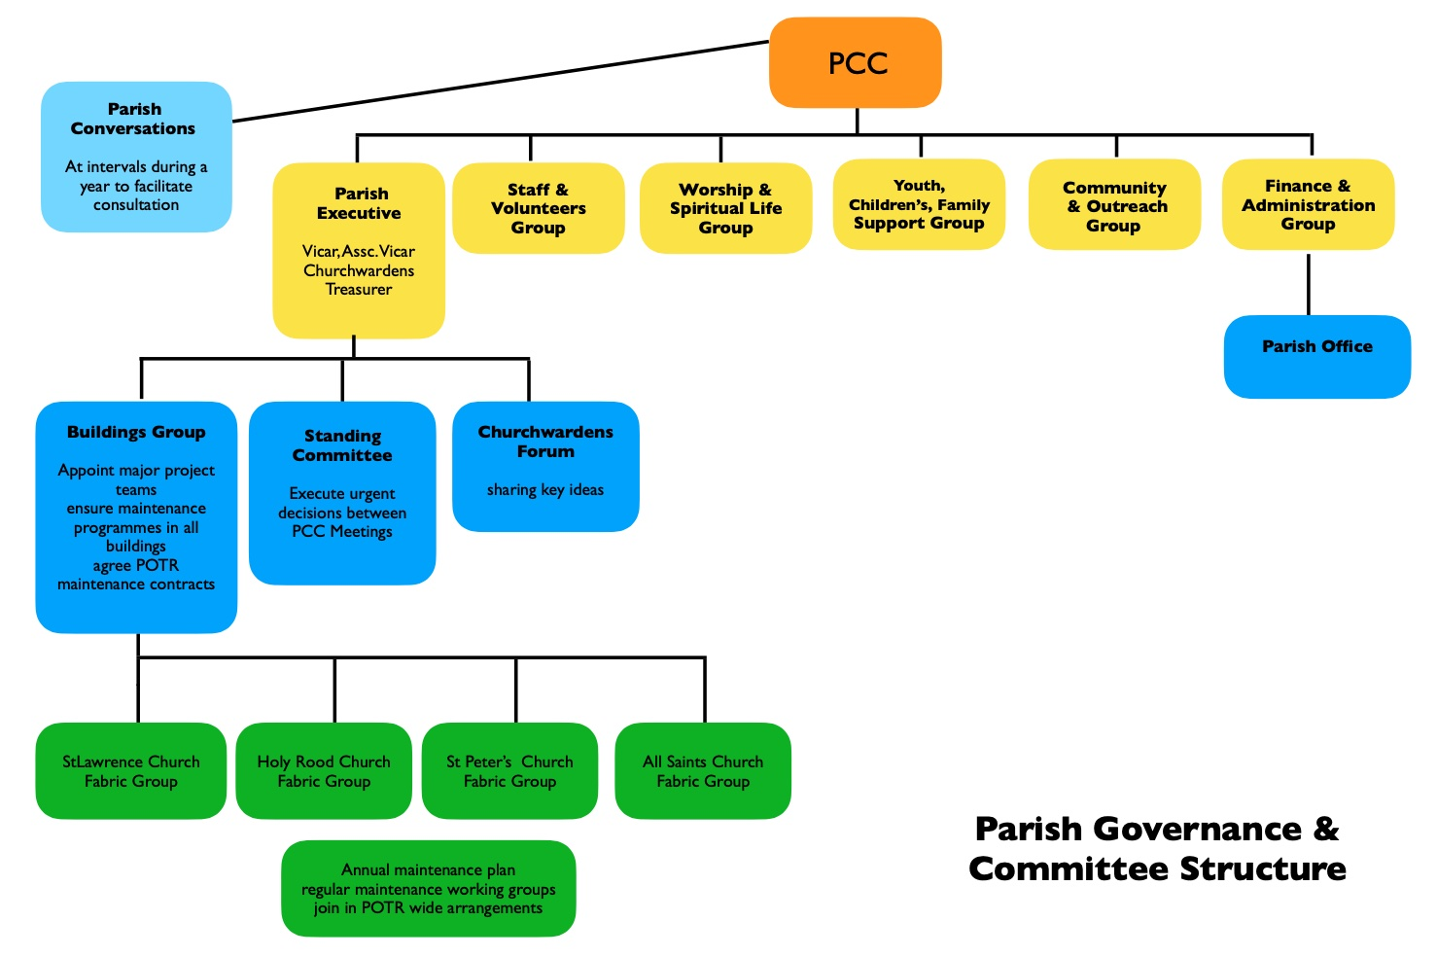

PCC & Group/Committee Protocols

The PCC and sub groups agenda and papers for each meeting will be circulated to members at least 5 days in advance

Every PCC agenda to include the opportunity for every group/committee to report and to include an item for particular discussion/conversation

Each report from a group to be written and circulated at least 5 days before the PCC meeting – each report to begin with an executive summary containing proposals and points for consideration by the PCC

The PCC and its groups/committees will hold regular and timely meetings according to the Terms of Reference

Membership of groups/committees will be reviewed annually at the first meeting of the PCC after the APCM

The minutes of the PCC and group reports will be made available to the parish community once they have been agreed. They will be available on the Parish Website and in each church building

A summary of each PCC meeting will be included on the Parish Website and in the Sunrise Magazine

Parish of the Resurrection Values

Proclaiming the Risen Jesus
Steadfast in Faith
Active in Service

As a welcoming, worshipping community of disciples of Jesus we are:

Rooted in prayer - learning the practices of being in conversation and relationship with God our Father through Jesus Christ our Lord. In everything we do prayer comes before, during and after.

Rooted in the Bible - believing that The Word of God directs and guides our individual and our communal lives. We read, mark, learn and apply it to all our decision making and parish life together.

Rooted in the gifts of the Holy Spirit - sharing what we all receive from Him to encourage and build each other up. We always want to be open to the possibilities of the present and future whilst valuing our heritage.

Rooted in partnership - looking to work with and alongside others who are building and extending the kingdom of God. We will work with each other across our parish, with other local churches and with community groups who have kingdom values at their heart.

Rooted in quality - seeking that whatever we do is the best we can offer and is attractive to those in our communities.

Rooted in fun - enjoying the life that we have and presenting the Church and our faith in Jesus with liveliness and boldness

Rooted in our care of creation - being good and wise stewards of the world’s resources and our environment. We will work towards the A Rocha Eco Church awards and Fairtrade status.

