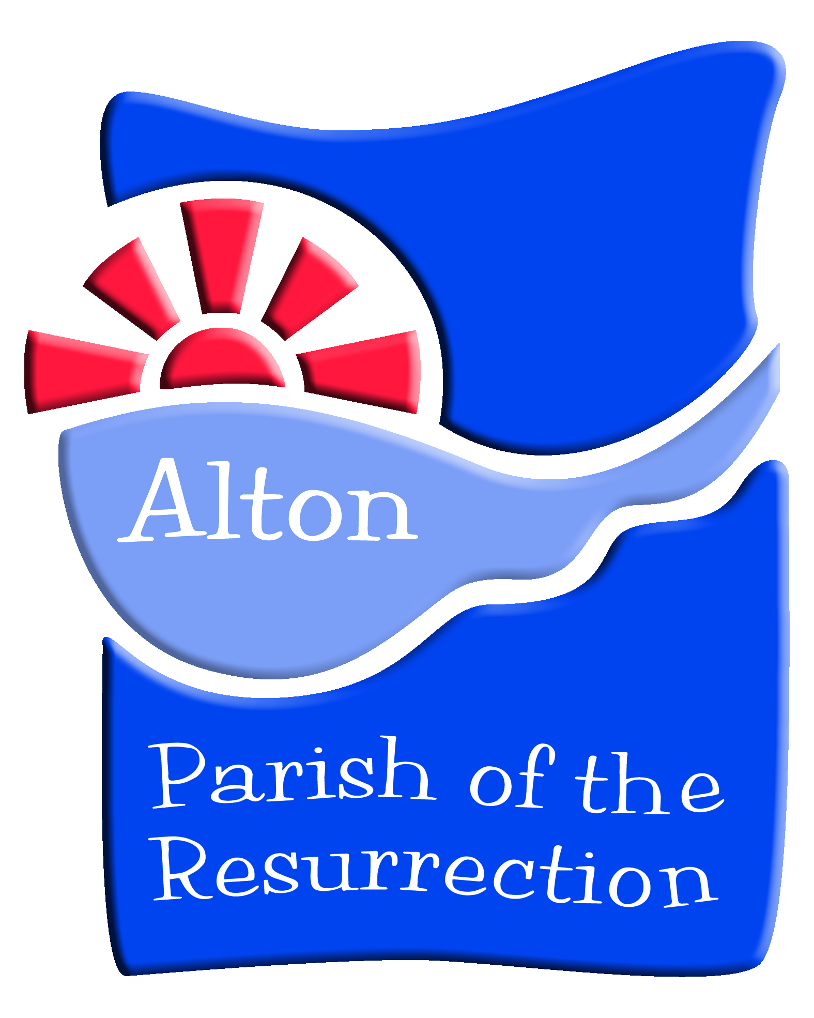
Parish of the Resurrection Alton
Communication Policy for Children and Youth Ministry

Last reviewed: July 2023
Next Review: July 2024

INTRODUCTION
As a community of faith, we need to be sure that clergy, staff, volunteers, and especially the children and young people we seek to serve, are kept safe in all areas of our ministry with regard to communication and social media.
All contact and communications with members of organisations and group leaders must be seen to be open and transparent. This is the case whether communications are by traditional means or electronic means.
Many young people regularly communicate using the internet and mobile phones. Using these methods effectively can:
- Help our youth ministry in the Parish of the Resurrection to stay connected with group members,
- Keep them up to date with what is planned, and
- Provide a platform to reflect on events and activities.
It is important, however, to use these platforms in a safe way to protect ourselves, the people with whom we work, and the Parish in terms of ministry and reputation.
Technology is growing at a fast pace and therefore the way in which young people communicate evolves quickly. Annual review of this policy, therefore will help us adhere to the guidelines of the platforms being used and that they are relevant to the time.
There are some key principles to remember when communicating electronically, and apply to all communication platforms:
- Leaders must not communicate with children or young people (0-18 years) via the leaders’ personal social networking profiles or email accounts. Messages must be in a group format with more than one leader in the group. Only children/young people who are known should be involved via communication in this way.
- Treat all communications as if they will be made public. Do not assume that a private communication will remain private.
- Do not ask anyone to keep a communication private.
- Do not assume that attempts to delete a communication have been successful on all devices and for all message recipients.
- Electronic communications pose a high risk of being misinterpreted as the normal nuances of conversation are missing.
- All communication should be broadly positive.
- The social media platforms discussed below all have minimum age requirements. At this time, and for consistency across communication, the minimum age is 13. We shall abide strictly by this requirement and do not agree to waive this requirement if requested to do so by a parent or guardian.
- Absent extenuating circumstances or unless necessary during an organized trip, staff and volunteers will not send communications outside of reasonable work hours. Reasonable work hours are between 9pm and 8am.
- Any communications that raise safeguarding concerns are to be saved, with screen shots forwarded to the Parish Safeguarding Officer.
- Consider carefully which, if any, abbreviations, symbols, emojis and abbreviations to include in messages. No abbreviations that can have ambiguous or leading meanings (such as ‘lol’) will be used. Conclude messages with the sender’s name and without ‘kisses’, etc.
Do not engage in online or telephone communication with children under the age of 11 who are Year 6 or younger. Communication about children of this age will be with the parents/guardians only.
The Children Youth and Families (CYF) Worker shall maintain a dynamic spreadsheet recording the permissions, or lack thereof, from parents/guardians pertaining to each child and young person. This document is carefully maintained at all times. When a young person turns 13, if the parent/guardian does not contact the CYF Worker, then the CYF Worker will contact the the parent/guardian to inquire whether any permissions have changed.
This policy makes some specific (but not all-inclusive) guidelines for some ways of communicating with young people under the age of 18.

INITIAL COMMUNICATIONS AND CONSENT FORMS
All communication regarding new arrangements for our Youth Ministry groups will be communicated by email, via the Parish database. This is to include timings and venues for Youth Ministry groups and for timings, venues, travel for trips and activities and events outside of the regularly scheduled groups. Once the initial communication has been sent by letter, follow-up reminders and changes of information can be conducted by email or phone call. Letters, emails, phone calls or conversations are the only direct ways of communication with parents/guardians.
Written and signed permission from parents/guardians must be obtained in advance, without exception, on the standard consent/information forms for each group and for the extra activities and trips.
Written and signed permission must be otained for use of social media as outlined in this policy.
Written and signed permission must be obtained for the taking of photographs of young people. Additional written and signed permissions must also be obtained for their use in any form of communication, including internal communications and external communication beyond the parish-led group, especially social media.
The current Youth Registration Form is available upon request from the parish administrator or CYF Worker. Paper and electronic copies are provided to prospective programme participants and their parents/carers.
For all types of direct communication with young people, signed and written permission must be obtained from parents/guardians. This permission must be specific to each social media platform – it can’t be a catch all!

EMAIL
Email is an appropriate way to send out information.
- Distributions lists are autogenerated through the IKnowChurch database system in use by the Parish. Recipients are able to reply privately to the sender, but cannot contact each other.
- An option to opt out of future emails is always an available to email recipients, with a statement to this effect included in every email as part of the sender’s “signature”. Regular review of email contact lists should be completed routinely within the cycle of Youth Ministry activities or at least annually to ensure all addresses are up to date and relevant to the messages being sent.
- All emails sent by staff, clergy and volunteers shall be written in a professional manner, using an appropriate salutation/greeting and containing an agreed “signature” at the end with contact information included.
- Note: signatures are not automatically included in database-generated emails; the user must remove the “opt out” feature and create a signature.
- All emails shall be positive and use language that avoids ambiguity.
- If a negative email is received it may be more appropriate to reply with an offer of a face-to-face meeting or a telephone call as these can lead to a clearer understanding.
- Group emailing is an appropriate way to communicate to a wide audience. Send this email to yourself and “bcc” all of the recipients’ email addresses to avoid sharing contact information as part of our compliance with the Parish’s Data Protection policies.
- When a participant leaves the group, the CYF Worker or other clergy or staff member will remove them from the communications. In general, this occurs when a young moves away, “ages out”, leaves for university or articulates an intention to leave and stops participating.
- If a child or young person has not participated in a youth programme for approximately six months, the CYF Worker will contact a parent or guardian to inquire whether the child or young person is interested in the continuing with the programme.

WHATSAPP
WhatsApp is a free instant messaging app available on all major carriers that uses the internet to send messages and is an effective way to let large groups of people know about events and activities. All WhatsApp “terms of use” must be strictly adhere
Text messaging has given way to group chats on WhatsApp and is the preferred method for sending out information.
- Use group messaging as a general standard procedure.
- The CYF Worker or other suitable adult—such as a co-leader or member of clergy—will set up the group chat and serve as admin(s). Young people and/or their parents are not to be added as group administrators.
- Avoid private messages to young people and/or their parents. If separate communications become necessary, ring them to speak by telephone.
- All communications will be on a Parish-owned device used and may be shared by numerous people on the ministry team.

INSTAGRAM
Instagram allows users to share photographs with followers. With enough followers are gained, it can be an instant visual way of showing events that are either happening now, or about to happen, to an audience.
- The Parish of the Resurrection has an Instagram account, as does the Blaze youth group.
- A minimum of two suitable adult admin users is required.
- Remember, once on the internet photographs are no longer private.
- The Youth Ministry Instagram page may be “followed” only by young people and shall not to be used to follow young people back.
- Parents/Guardians are always invited to follow the page so that communication is open and transparent
- The Youth Ministry Instagram page must only be used to follow projects, events and activities promoted by or consistent with the values and ministries of The Parish of the Resurrection, as determined by the clergy and CYF Worker.
- Instagram shall not be used as a direct messaging service within the Parish of the Resurrection.
- All Instagram “terms of use” must be strictly adhered to.

SNAPCHAT
SnapChat is an instant messaging platform that sends a photograph to groups or individuals that only lasts for a set amount of time before it is automatically deleted. Users can, however, screen grab an image. This platform is inappropriate in the context of the Parish of the Resurrection. No Parish clergy, staff or volunteers will have any young person under the age of 18 on their SnapChat follow list.

TWITTER
The Parish of the Resurrection has a Twitter account, maintained by the admin team, who follow standard procedure with social media contacts. Twitter shall not be used by the CYF Worker or team for any programmes,

FACEBOOK
Facebook is an effective way of communicating to large groups of people and to individuals quickly.
- The Parish has a Facebook page maintained by clergy/staff.
- All requests to join the group will be adjudicated by a the CYF Worker or a member of clergy/staff.
- Adults involved in leading CYF programmes will not follow as a “friend” a young person who is under the age of 18 unless the leader is a relative or godparent.
- When a young person involved in a CYP programme turns 18, they are to be instructed by a programme leader to remove from their Facebook accountsfriends who are under 18.
- Facebook Messenger shall not be used for Youth Ministry purposes in the Parish of the Resurrection.

OTHER SOCIAL MEDIA AND COMMUNICATION PLATFORMS
The following social media platforms are not to be used for CYF programmes:
- TikTok
- YouTube
- Zoom
- Skype
- BeReal

STORAGE
Images taken by leaders should be taken on parish-owned equipment (phone/camera) rather than personal mobile phones where possible. They should then be stored safely in an electronic file on devices that have security passwords. Where possible, these devices should also be owned by the parish, not the group leader. Photos should not be taken on personal devices unless they can be moved immediately to parish storage and all backups removed from the device. Be aware of apps such as Google Photos, which by default will automatically upload any photos taken on a device to the cloud. If in doubt, do not take photos. If any electronic device/memory that contains video or images is disposed of, then the images and video should be wiped from the memory in such a way that they cannot be recovered on that device.

MOBILE PHONES
Most people now have access to a smart phone, so it is important for leaders to guide group understanding around when it is and is not appropriate to be on the phone during an event or session, in particular around the usage of the camera for both photography and filming. It is also leader’s responsibility to guide young people on what is an acceptable use of the phone. Situational Awareness is important. Mobile phones should not be allowed where they would be a distraction from a safe awareness of the environment. In any event or session when phone access is restricted, parents/carers must be made aware of a leader whom they can contact in case of an emergency

REMINDER

Contact the Parish Safeguarding Officer if you have any safeguarding concerns about a child or young person, and always follow the safeguarding policies, procedures and guidance.

